M4 LAB DISTRIBUTION IN R

ASSIGNMENT

NAME: CHARLES WIREDU

STUDENT ID: 901379751

Please use seq () to create a variable X with range from 1 to 10 and length 1000.

*SOLUTION*

Please plot (gamma) probability density for X.

*SOLUTION*



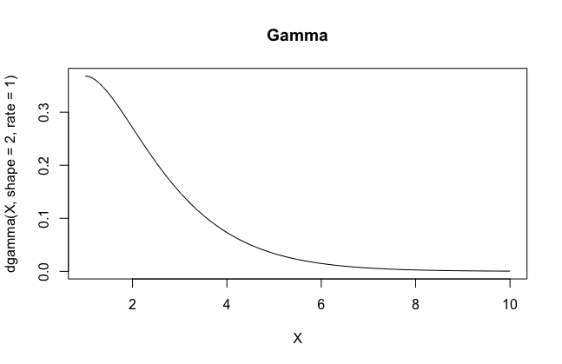

* Please extract "Ozone" data vector from the built-in dataset "airquality" and plot Empirical Cumulative Distribution. Please add title, x and y labels for your graph.

*SOLUTION*

